Name: Noah Nguyen

R Lab 5: Confidence Intervals

Please answer all the Exercises and the questions from the “On Your Own” section. If you use any graphs or charts to justify your answer, please include them.

Exercise 1: Describe the distribution of your sample. What would you say is the “typical” size within your sample? Also state precisely what you interpreted “typical” to mean. (Include plot.)

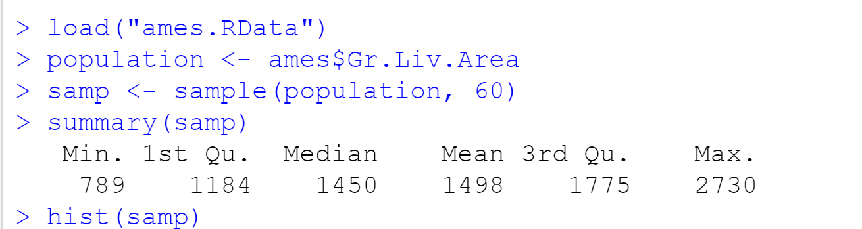
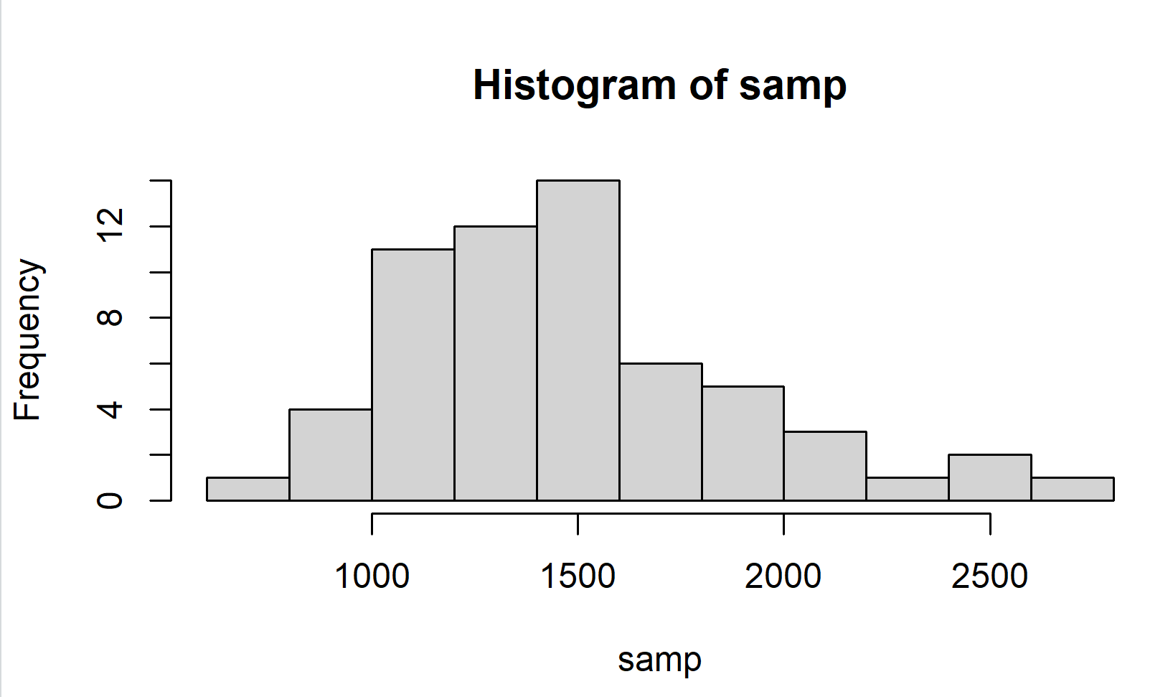
This distribution is right-skewed, with a mean of 1498 and a median of 1450. The typical size is the sample mean, which represents the average size of the house in Ames.
Exercise 2: Would you expect another student’s distribution to be identical to yours? Would you expect it to be similar? Why or why not?

Another student’s distribution is not identical since the sample might be different but it will be similar to my distribution because the sample is taken from the same dataset so the distribution follows the same trend.
Exercise 3: For the confidence interval to be valid, the sample mean must be normally distributed and have standard error $\frac{s}{\sqrt{n}}$. What conditions must be met for this to be true?
- The sample is random and independent.
- The sample size is more than 30.
- The distribution is not significantly skewed.

Exercise 4: What does “95% confidence” mean?
95% confidence means we are 95% confident that the sample has the true mean falling into the 95% confidence interval.
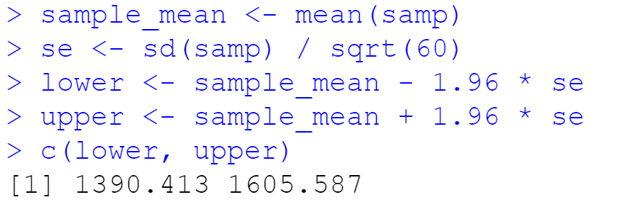
Exercise 5: Does your confidence interval capture the true average size of houses in Ames?

Yes, my confidence interval does capture the true average size of houses in Ames.
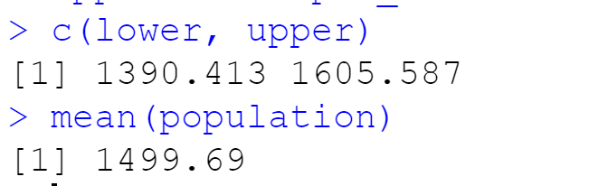
Exercise 6: Each student in your class should have gotten a slightly different confidence interval. What proportion of those intervals would you expect to capture the true population mean? Why?

It is expected that the 95% confidence interval captures the true population mean because the intervals are all built with 95% confidence.
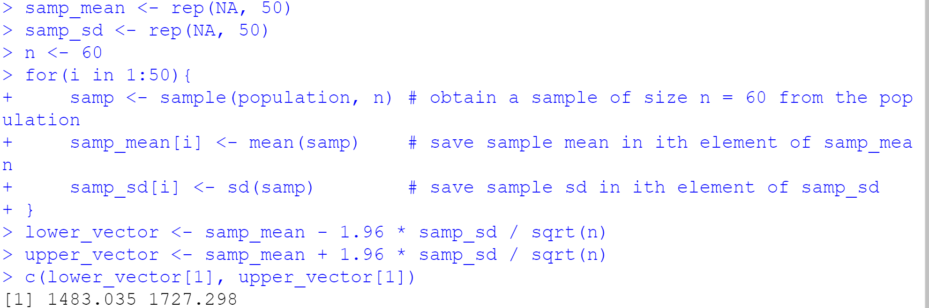

On Your Own:
1) Using the following function (which was downloaded with the data set), plot all intervals. What proportion of your confidence intervals include the true population mean? Is this proportion exactly equal to the confidence level? If not, explain why. (Include plot.)
plot_ci(lower_vector, upper_vector, mean(population))
1 out of 50 random samples does not contain the true population mean. That means that 98% of my confidence interval includes the true population mean. This is not exactly equal to the confidence level, which is 95%.
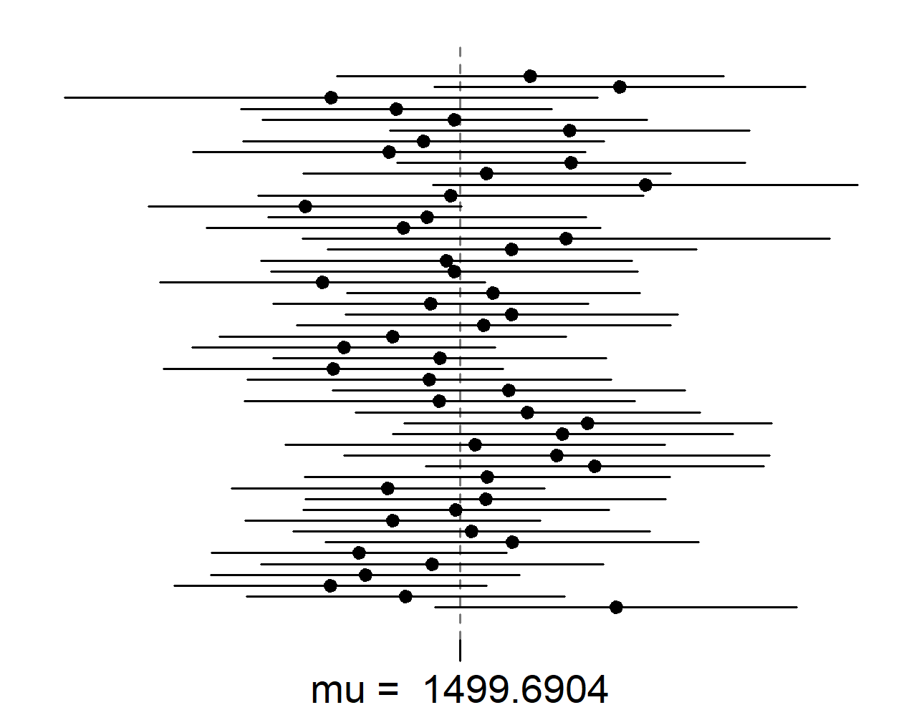

2) Pick a confidence level of your choosing, provided it is not 95%. What is the appropriate critical value $z_{α/2}$ or $t_{α/2}$?
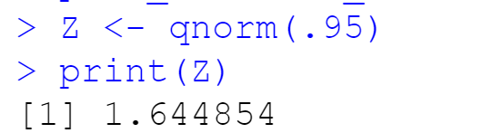
I picked 90% confidence level with a corresponding level of 0.95. The critical value is 1.644885, which is close to the value of 1.645 that we have in the table.

3) Calculate 50 confidence intervals at the confidence level you chose in the previous question. You do not need to obtain new samples, simply calculate new intervals based on the sample means and standard deviations you have already collected. Using the plot_ci function, plot all intervals and calculate the proportion of intervals that include the true population mean. How does this percentage compare to the confidence level selected for the intervals? (Include plot.)
From this sample, 46 out of 50 (92%) include the true population mean. The previous confidence level is 90%. Since 92% > 90%, I’d say this is a pretty good confidence level.
